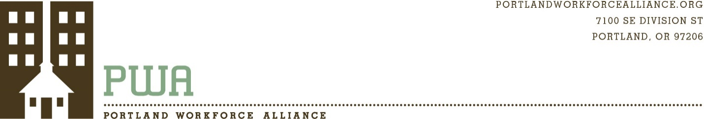

Communications and Program Manager

Posted: June 18, 2018
Closed: When filled

MISSION OF PORTLAND WORKFORCE ALLIANCE
The nonprofit Portland Workforce Alliance is a coalition of business, labor, high schools and postsecondary institutions. PWA works with local employers and educators to provide real-world learning experiences that teach students about career opportunities and help them see how today’s educational choices can open doors to great jobs. Our mission is to improve Oregon’s graduation rate; build a strong, diverse and well-educated workforce; and help regional employers develop their pipeline of talent. PWA’s board and volunteers see young people as the key to our region’s long-term economic prosperity and quality of life.

JOB DESCRIPTION
Our independent nonprofit is looking for a motivated individual to join our team and help further our mission through effective communication and program management as we work with partners to provide meaningful career-education experiences for high school students. The successful candidate is a versatile team player who knows how to inform and inspire across multiple platforms. The ideal candidate will have experience furthering an organization’s mission through writing, photography and graphic design, and through using social media to reach partners and supporters. In addition to key communication responsibilities, this individual will assist with program needs, such as volunteer coordination and Career Day staffing. Each staff member is seen as essential to PWA’s effort to serve a diverse community and build sustainable partnerships between high schools and employers.

PRIMARY RESPONSIBILIITES
- Collaborate with PWA staff to improve the effectiveness of our communication with educators, employers, donors and volunteers.
- Work with PWA team to manage and document experiences (career days, mentorship programs, Careers Expo, classroom presentations, etc.) that educate students about career opportunities and the skills required to be successful in the workplace.
- Use skills in graphic design, writing, photography, photo editing and video to create marketing materials, flyers, evites, monthly e-newsletters, blog posts, photo galleries and other materials to successfully promote the work and partners of PWA and the ACE Mentor Program.
- Manage the social media presence of PWA and the ACE Mentor Program.
- Manage and update the website of PWA, including the calendar and blog.
- Assist with grant-writing and fundraising.
- Compile and summarize student and employer evaluations to support program quality and partner retention.
- Use Salesforce to help manage our contacts and support efficient communication.

QUALIFICATIONS
- 2-5 years of communications experience
- Exceptional interpersonal communication skills
- Excellent writing and editing skills
- Experience with Adobe Creative Suite (InDesign, Photoshop, Illustrator)
- Knowledge of Microsoft Office and Google Suite
- Experience with event and program marketing via social media
- Ability to multi-task and mange deadlines through superior organizational skills
- Experience interacting with diverse groups of people
- Positive and helpful demeanor
- Commitment to provide excellent service to educators, employers and students

PREFERRED SKILLS/EXPERIENCE
- Experience with CRM software (such as Salesforce)
- Experience with MailChimp and Eventbrite
- Experience with video creation, editing and storytelling.
- Experience with grant writing and fundraising

HOURS, PAY AND BENEFITS
- Part-time (30+ hours/week) or full time depending on candidate fit.
- Pay range $20 - $24/hour DOE
- Competitive benefits package includes employer-subsidized health insurance, short-term disability coverage, life insurance, paid holidays, sick time and earned vacation.

How to apply:
Send a cover letter and resume to jobs@portlandworkforcealliance.org, Please attach or link to 2-5 examples of your work products that demonstrate effective communication, and describe your role in those products (can be writing, multimedia, graphic design, web design, etc). Please use the cover letter to specify why you are interested, what skills you would bring to the organization, how you have helped an organization grow or improve, and whether you prefer part time or full time.

