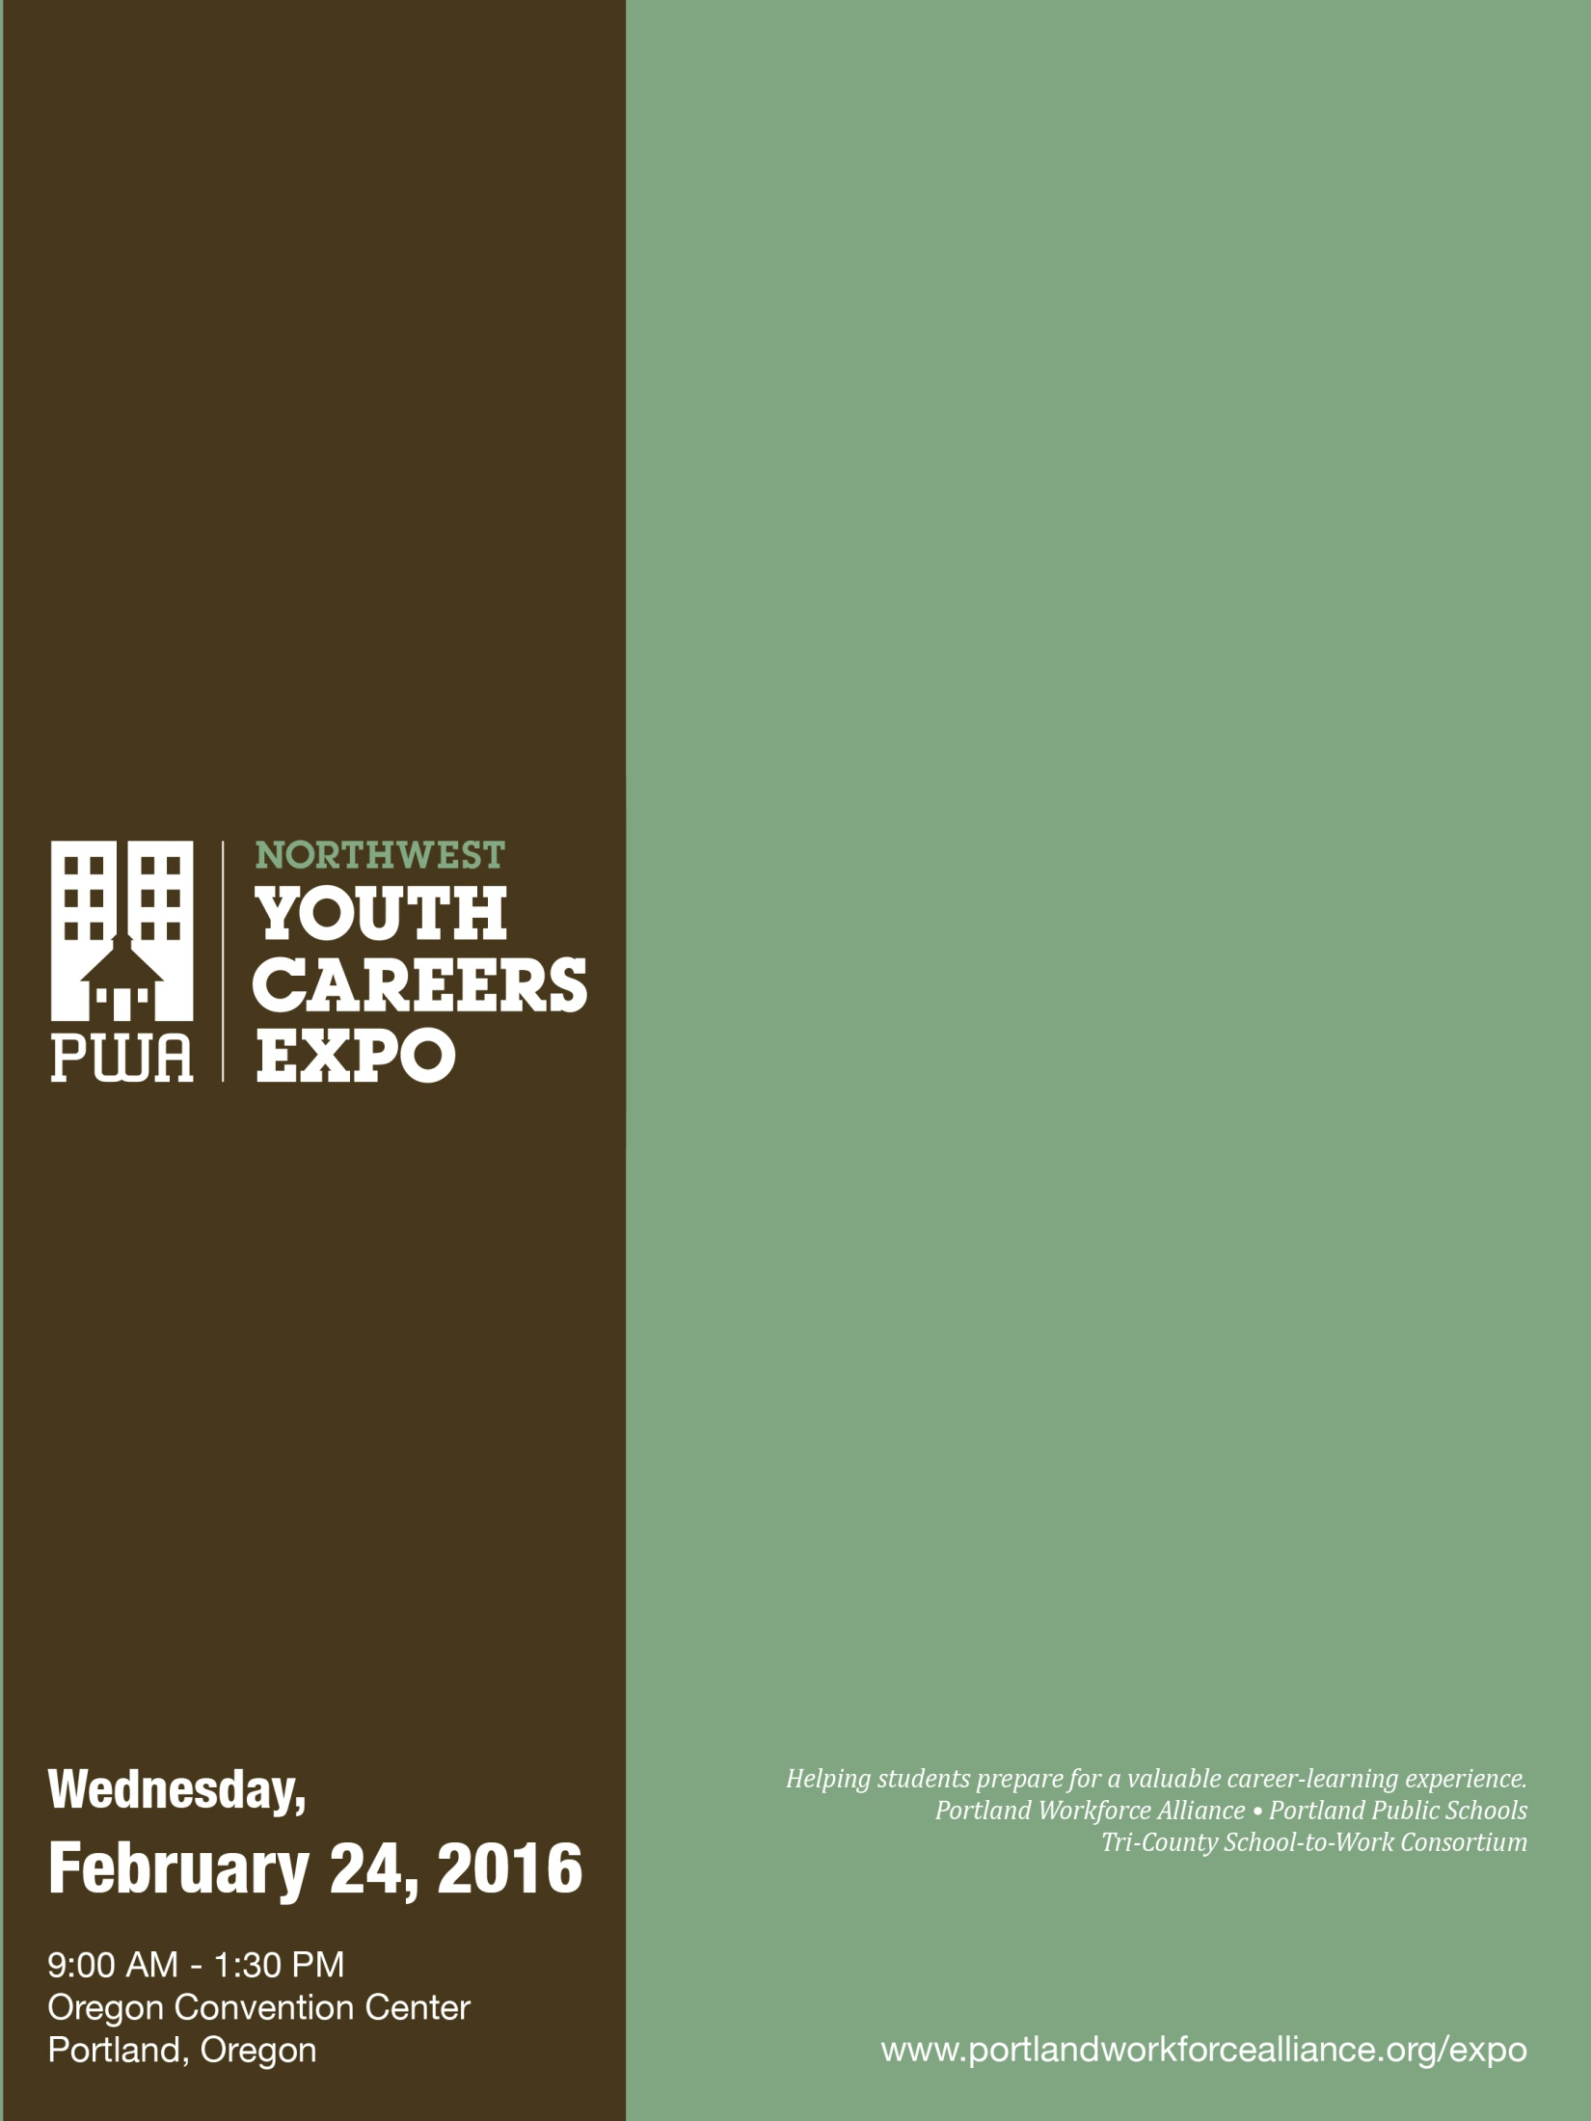
Teacher Packet

What's inside:
- Teacher checklist for Expo day
- Student tips and video links
- Sample Expo assignment
- Classroom exercise before the Expo
- Sample permission slip

Your school’s registered time at Expo:

Teacher Checklist for Expo Day

Before Departure
- Permission Slips: Make sure every student has a signed permission slip.

On the bus
- Behavior: Review appropriate behavior for the Expo.
- Activities: Remind students about the Mock Interviews and Exhibit Hall (the Resource Guide at the door has a map & directory)
- Distribute hand-outs (i.e. Career Expo assignment, etc.)
- Check In: If possible, have students check in with an adult chaperone half way through the Expo. Tell them what time and where to meet their chaperone. Time: Location:
- Exit: Remind students of the time and place to meet for leaving the Expo.
Time: Location:
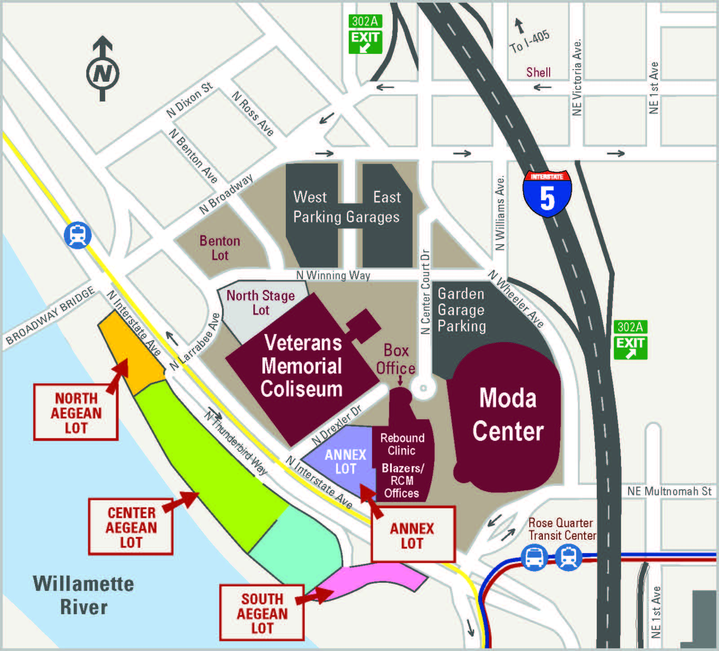
- Let the bus driver know:
  - PPS buses need to go back to the bus barn
  - All other buses should park at the Rose Garden, behind the Veterans Memorial Coliseum, in the Benton Lot
  - No buses can park in the Lloyd Center area
  - No buses can park in the bus pull outs on Holladay or MLK

When You Arrive
- Instruct buses to drop off students on the Holladay Street (north side of the convention center) bus pull outs or the MLK bus pullouts. Remind the bus driver not to park here. See bus instructions above.
- Coordinate with your bus driver to know how to easily find your bus. There will be many buses waiting outside of the Convention Center, so make sure you decide how students will find your bus. Suggestions include getting phone number of driver, putting a color or number in the window of the bus, or other ways to quickly identify which bus belongs to your class/school.
- Check in with the information booth near the Expo floor so they know your school has arrived. Let them know how many students are attending and what time your bus will be leaving.
- Announcements will be made in the exhibit hall to remind your students prior to bus departure time.

When You Leave
- Checking out: Let organizers at the info/check-in booth know your school is leaving.
- On the bus: If you want students to complete a reflection, remind them to finish this activity.
Preparing Students for the Expo
Thank you for bringing your students to the NW Youth Careers Expo. You’re helping your students find their career aspirations, and we appreciate your work in making this educational opportunity happen.

The Expo can be overwhelming to students who aren’t prepared. Please take time to review this information with your students. The more prepared students are, the more they gain from their Expo experience.

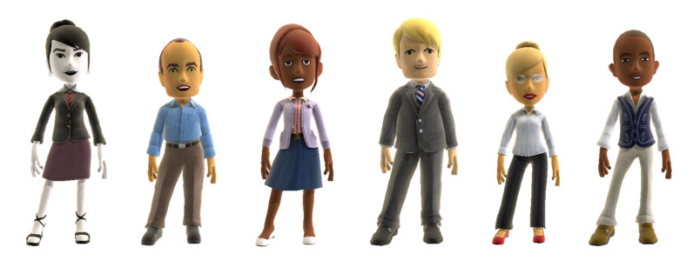
STUDENT ATTIRE
Dress is business casual, or what you would wear to a job interview. Please remind students that they represent their school. Also, encourage students to choose business-casual attire and shoes that allow them to participate in activities and demonstrations (i.e. climbing a ladder, etc). If students hope to participate in a mock interview, we strongly recommend that they dress professionally.
- Professional business casual dress requested
- Students doing mock interviews should dress professionally
- No shorts, caps/hats, t-shirts with inappropriate logos/graphics; jeans are OK if in good condition

BEHAVIOR
Let students know that companies have donated a lot of time and money to make the Expo successful. We have tremendous employer commitment to this event and we want to continue these partnerships. Please encourage students to thank the employers for taking the time to participate in the Careers Expo.
- Students should display professional behavior to Expo exhibitors
- Students are representing their schools at all times
- Remind students to thank the employers for the time and information they have provided to them

EXPO VIDEOS We have two short online videos for you to show your students and help them get prepared.
- One is a 1-minute photo montage offering “5 tips for a great Expo.”
- The other is two-minute video montage showing footage from the Expo floor.

VIDEO LINK: Go to www.portlandworkforcealliance.org/expo and visit the “Tips for students” section. Share the link with your students if classroom time doesn’t allow for the videos to be shown.

CAREERS EXPO STRUCTURE
The Expo has many opportunities for students. Please remind them of the following options:
- Visit 130+ booths in the main hall floor where employers provide hands-on demonstrations and talk with students about their educational paths. Students will also have the chance to learn about the skills & education needed to be successful in that field.
- Meet representatives from training schools, apprenticeships, community colleges and universities.
- Participate in “hands-on” learning activities (i.e. working with robots, trying out equipment from hospitals and other employers, etc.) in the demonstrations area.
- Participate in a mock interview (located in A area). This is students’ chance to interview without the pressure and receive tips from human resource professionals.
- Receive feedback on writing a resume and completing a job application.

Expo Career Activities

BEFORE THE EXPO

Portland Workforce Alliance website: PWA is a nonprofit that organizes this event. Visit the PWA website at www.portlandworkforcealliance.org for great Expo resources, and encourage students to do the same.

Permission Slip: Attached is a sample permission slip. At the bottom, students sign that they understand the guidelines for dress, behavior, etc. for the Expo. You might want to copy the Career Reflection on the back so students know what type of questions they will need to answer after the Careers Expo and review this ahead of time. In addition, you may need to add your district’s pre-arranged absence form.

Career Assessment:
- Students take a career assessment in CIS, Naviance or another on-line career assessment tool.
- After they have identified the careers they are interested in, show them the list of exhibitors (at the Expo section of PWA’s website and have them select at least five employers they want to visit.
- Have students brainstorm questions for these exhibitors. For example: What skills are necessary for this career? What type of education/training do you need? What is the salary range for someone working in this field? What do you like most about your job, and what are the biggest challenges?

Post-Secondary:
- Have students brainstorm questions about post-secondary options.
- Have students research college programs that lead to the careers of interest from their assessments.
Resume: Students can complete a resume and bring it to the Expo so they can have an HR professional review it and give feedback at a mock interview or resume workshop. (See PWA website for more details.)

Mock Interview: Summer is coming and many students are looking for jobs and internships. Virtually all students benefit from practice sharing their goals and communicating with confidence and professionalism.
- Have students select a business they are interested in applying to and research it.
- Tell them about the mock interview room (in the A area) where human resource professionals will be conducting practice interviews to help them prepare for future interviews.
- Don’t forget to remind students to dress professionally.

Important note about Mock Interview logistics: More than 1,000 students will be seeking mock interviews at the Expo, which requires traffic management. We have spaced schools’ arrival times throughout the day and asked schools upon arrival to send half of their students to the Expo floor and the other half to mock interviews. Please come at your assigned time, and please do not create a traffic jam by sending a high volume of students to mock interviews at unplanned times! Thank you very much. Your cooperation will help keep the wait manageable and allow students to make the most of the educational opportunities at the Expo.

Pre-Event Questions: Attached in this packet.

DURING THE EXPO

Career Expo Assignment: Attached in this packet

AFTER THE EXPO

Career Expo Reflection: Have students complete the attached questionnaire. In class upon return, have them “pair share” or divide in to small groups to share their answers (have students from different career areas represented).

USE BEFORE THE EXPO
2016 NW Youth Careers Expo Name: Grade:
Pre-Event Questions
MAKE A PLAN!
- Which best describes you?
- I’m a hands-on type of person.
- I’m a people person!
- I’m the idea person.
- I’m the information and data person.

- Which Career Pathways might be a good fit for you?

- Arts & Communication
Career fields include designer, artist, writer, musician, public relations professional, communications specialist.

- Business & Management
Career fields include finance, accounting, marketing, sales, human resources.

- Health & Medical Services
Career fields include doctor, physical therapist, nurse, radiologist, medical lab technologist.

- Human Services & Helping Professions
Career fields include police officer, detective, teacher, counselor, psychologist, social worker, family support, nonprofit work, fire/emergency services.

- Industrial & Engineering Systems
Career fields include computer software engineer, civil engineer, electrician, architect, manufacturing, construction.

- Natural Resources & Science
Career fields include veterinary services, agriculture, horticulture, wildlife, forestry, fisheries, environmental scientist, landscape architect.

- I have no clue! However, I would like to talk with …..
over
- You will get an Expo Guide listing all of the exhibitors. The index will list companies and schools by Career Pathway. Using the career pathway(s) listed above, write in companies and/or schools that you would like to visit today and find them on the map in the brochure.

- Here’s one great way for high school students to get experience in a career area while in high school: community service and volunteering! Identify at least one exhibitor who offers community service and volunteer experience for youth (i.e. Mercy Corps, American Red Cross, Portland Parks and Rec, Oregon Humane Society, etc).

- Looking for a job, internship or community service opportunity? The Portland Human Resources Managers Association brings more than 100 human resource managers to interview students. Before you visit this area (in the A Exhibit Hall), write one or two questions you think a supervisor might ask you and prepare answers. You can review this with one of the human resource managers.

- What do you hope to get out of the event today?

USE DURING THE EXPO
2016 NW Youth Careers Expo Name: Grade:
Pre-Event Questions
2016 NW YOUTH CAREERS EXPO ASSIGNMENT

Practice talking to adults about the world of work.
Career Related Learning Experiences are required for graduation. This short assignment is your proof of participation.

Pick a company that you don’t know much about and visit their booth to collect information.

Ask 3 – 5 questions so you can write a one paragraph summary about the company. You can use the following big and small questions with everyone you meet, but you only have to write a summary about one company. Make up some questions of your own, too.

BIG questions:
- What do you want teens to know about your company?
- How has your business changed to adapt to changes in the industry, economy or culture?
- Where do you think your company will be in years when I get out of high school/college?
What kind of jobs will you be hiring for?

SMALL questions:
- What does your company do?
- How many people work for you in Oregon? Worldwide?
- I’m a (people person/hands-on, etc.) type of person.
What kinds of work does your company have for a person like me?
- What kind of educational paths would you recommend for someone who wanted to work at your company? What kinds of classes, training or experiences would be helpful?
- What are some entry level jobs that high school graduates can get?
- Do you offer internships or summer employment?
My favorite part of the Expo was:

Company Summary:

USE AFTER THE EXPO
2016 NW Youth Careers Expo Name: Grade:
Pre-Event Questions
CAREERS EXPO REFLECTION

Pick one of the industry areas that you visited during the Expo:

❑ Arts & Communication  Business & Management  Manufacturing & Technology
❑ Natural Resources  Human Services (law, public service)  Health Care

Within this industry, what type of career(s) are you interested in?

Explain why this area interested you:

Describe three things that you learned about this industry that you didn’t know before:

1.

2.

3.

over
What type of education or training do you need to get started in this industry?
What do you need to advance?

What kinds of skills do you need to succeed in this industry? (i.e. math skills, writing ability, computation skills, critical thinking, public speaking, budget analysis, project management)

List three personal attributes that this employer is looking for in a new employee (i.e. teamwork, creativity, punctuality, etc).

1.

2.

3.

OPTIONAL PERMISSION SLIP TEMPLATE
2016 NW Youth Careers Expo Name: Grade:
NW YOUTH CAREERS EXPO
Wednesday, Feb. 24, 2016
Oregon Convention Center
777 NE MLK Blvd., Portland, OR 97232
www.portlandworkforcealliance.org/expo

Students are invited to participate in the NW Careers Expo with more than 100 employers and exhibitors providing essential career information. Students will learn about opportunities in Business, Health Services, Technology, Arts, Manufacturing, Construction and Natural Resources. Students will also have a chance to participate in mock interviews, learn about college programs & more. Participating in the NW Careers Expo counts as CRLE (Career Related Learning Experience) toward your diploma requirements.

Questions?
School contact name: Email/phone:

Parents/guardians: Please sign the form below so your child may participate in the NW Careers Expo.
A signed form functions as permission for your child to be included in Expo photos/communications.

has my permission to attend the NW Youth Careers Expo on Wednesday, February 24, 2016, at the Oregon Convention Center.
Parent/Guardian Name: (PRINT) | Parent/Guardian Signature:
Emergency Contact Name: | Emergency Contact Phone:
Student Agreement: By signing this form, I am agreeing to the below guidelines. I agree to:
- follow business-casual dress code. No hats, shorts, sweats, bare midriff, short skirts, ripped jeans.
- participate in the learning activities and engage in dialogue (ask questions) of Expo representatives.
- use respectful communication that is professional in both language and tone and that reflects positively on myself and the school I am representing.
- thank the employers I spoke with for their time.
Student Name: (PRINT) | Student Signature:

