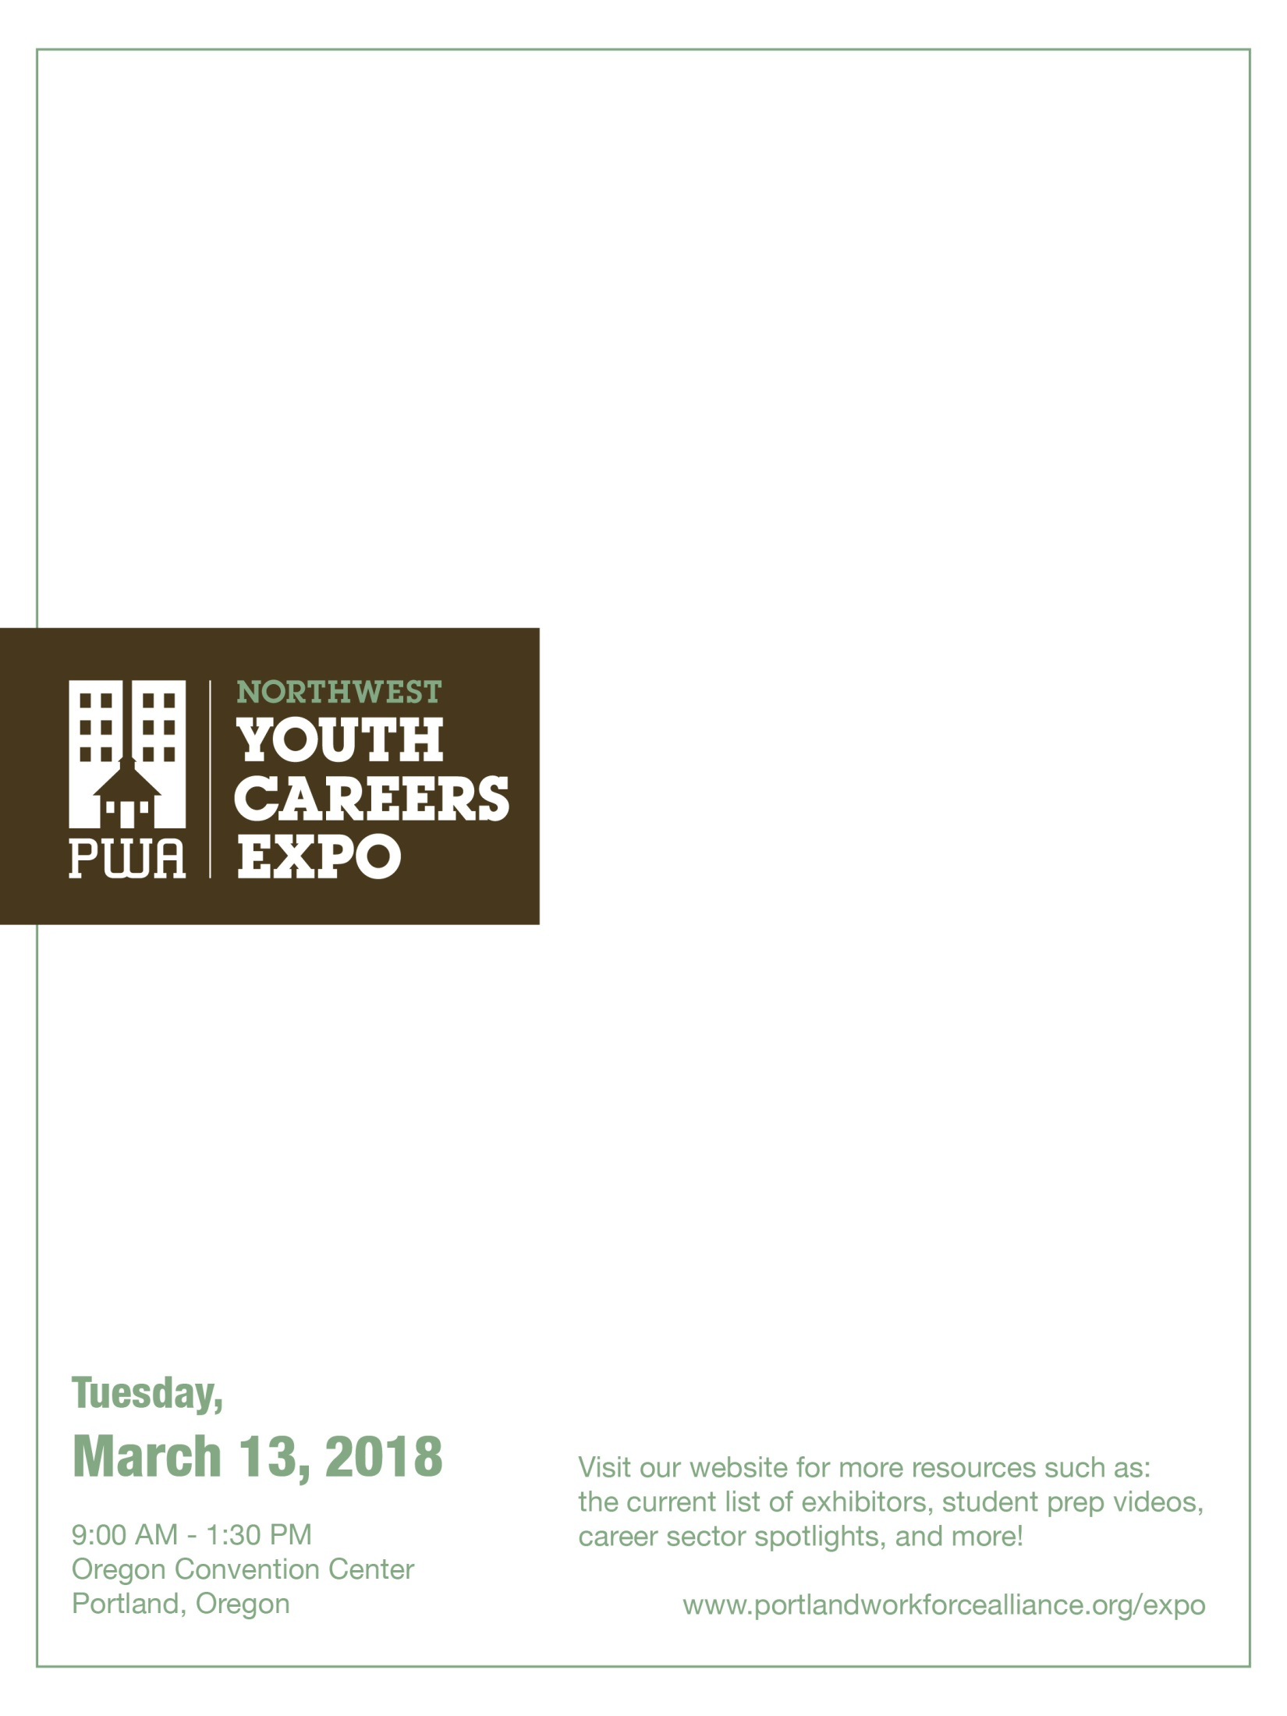
Teacher Packet

What's inside:
- Teacher checklist, p. 2
- Preparing students, p. 3
- Sample student activities:
  - Before the Expo, p. 4
  - During & after the Expo, p. 5
- Student tips and video links, p. 6
- Sample classroom exercise, p. 7
- Sample Expo assignment, p. 9
- Sample Expo reflection, p. 10
- Sample permission slip, p. 12

Your school’s registered time at the Expo: _________

Teacher Checklist
6-8 weeks to go
- If you want your students to participate in mock job interviews at the Expo, sign up early. (See p. 5)
2-3 weeks to go
- Check the PWA website for new information about Expo employers and featured sectors.
- Review teacher resources here and online. Consider classroom activities to help prepare students. (See p. 7)
1 week to go
- Make sure every student has a signed permission slip.
- Check out the official 2018 Expo Resource Guide, which includes a map & directory.
This will be available online and sent to schools about 4-7 days prior to the Expo.
- Review any final bus instructions. Final bus information will be emailed to schools prior to the Expo.
Expo Day!
Coordinate with your bus driver:
- Know how to find your bus after the Expo. There will be many buses waiting for students outside the Oregon Convention Center, so make a plan. Suggestions: know driver’s cell number, put number or sign in the window, etc.
On the bus:
- Review appropriate behavior for the Expo.
- Review activities and features, such as the exhibit hall, mock interviews and career talks. Tell students to pick up a printed Expo Resource Guide at the door with map & directory.
- Distribute your own handouts (i.e. Career Expo assignment, etc.)
Reminders:
- Check in: Some schools tell students to check in with an adult chaperone halfway through the Expo.
Remind them when and where to meet their chaperone. Time: _____ Location: _____
- Exit: Remind students of the time and place to meet for leaving the Expo. Time: _____ Location: _____
When you arrive:
- Check in at the information booth near the Expo floor. They need your arrival time, number of students and departure time.
- Announcements will be made in the exhibit hall to remind your students prior to bus departure time.
When you leave:
- Check out at the info/check-in booth. Let organizers know your school is leaving.
- If you want students to complete a reflection, remind them on the bus to finish this activity.
Preparing Students for the Expo

Thank you for bringing your students to the NW Youth Careers Expo. We appreciate your work in helping students develop their career aspirations. The Expo is a chance for students to explore careers in fields such as health care, technology, construction, manufacturing, energy, arts & communication, and public service.
The Expo is huge and can be overwhelming to students who aren’t prepared. Please review this information with your students. The more prepared students are, the more they gain from their Expo experience!

What Can Students DO at the Expo?
- Career Exploration: Visit 170+ booths in the main hall floor where employers provide hands-on demonstrations and talk with students about their educational paths. Students will also have the chance to learn about the skills and education needed to be successful in different fields.
- College Exploration: Meet representatives from community colleges, universities, training schools and apprenticeship training centers.
- Hands-On Activities: Participate in “hands-on” learning activities (i.e. working with robots, trying out equipment from hospitals and other employers, etc.).
- Mock Interviews: Interview without pressure and receive tips and feedback on their resume and communication skills from caring HR professionals.
- Career Talks: Sit in on a 20-minute career talk, given by an HR professional, on landing a job or acing an interview. (See p. 5)
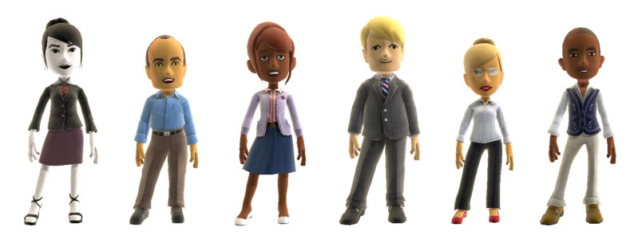
What Should Students Wear?
- Please dress in “business casual” attire, or what you would wear to a job interview.
- Consider shoes and attire that allow you to participate in hands-on activities and demonstrations (i.e. climbing a ladder).
- Students doing mock interviews should dress professionally.
- No shorts, caps/hats, t-shirts with inappropriate logos/graphics. Jeans are OK if in good condition.

What about Student Behavior?
- Students should display professional behavior toward Expo exhibitors.
- Students are representing their schools at all times.
- Encourage students to thank the employers for the time and information.
Teachers: Employers support the Expo financially and with volunteer time. We have tremendous employer commitment and want to continue these partnerships. Thank you for preparing your students!
BEFORE the Expo: Sample student activities

Use resources from the PWA website
Portland Workforce Alliance is the nonprofit organization that organizes this event.
Go to www.portlandworkforcealliance.org/expo for all Expo resources, including:
- A Tips for Students page, which includes fun advice and a link to teacher resources
- A Mock Interview page with handouts and other tools
- An Expo photo gallery and a fun 1-minute Expo highlights video
- An Exhibitor page

Do a Career Assessment and Expo Plan
- Students can take a career assessment in CIS, Naviance or other online tool.
- After students identify career interests, show them the list of Expo exhibitors
and have them select at least five employers they want to visit.
- Have students brainstorm questions for these exhibitors. (See page XX.)

Research College/Training Options That Support Career Goals
- Students can brainstorm questions about post-secondary options, then research
college and training programs that lead to the careers of interest from their assessments.

Have Students Make a Resume and Prepare for an Interview
- Students can complete a resume and bring it to the Expo so they can have an HR professional review it and
give feedback during a mock interview. (See mock interview section for information about signing up.)
- Have students select a business they are interested in applying to and research it.
They can share that information with their interviewer at the Expo.

Use the Permission Slip as a Planning Tool:
- Review the sample permission slip attached. At the bottom, students sign that they understand the guidelines for dress, behavior, etc. for the Expo. (Your school may have its own permission slip or absence form.)
- Copy the Career Reflection on the back so students know what type of questions
they will need to answer after the Careers Expo.

DURING the Expo: Sample student activities
Complete a Career Expo Assignment
- Use or adapt the sample assignment in this packet to help students engage.

Attend a Career Talk
- Encourage students to attend a 20-minute Career Talk on a topic such as Landing a Summer Job or Acing Your Job Interview. (Look online for final schedule and topics.)
- These drop-in sessions will be given by seasoned HR professionals and held every half hour near the mock interviews. Students will receive a Certificate of Completion.

Look for “Lightbulb” employers
- Many employers who offer summer jobs, internships, volunteer work and other opportunities for high school students will have a “Lightbulb” sign at their booth.
- Encourage students to find 1-2 employers with “Lightbulb” opportunities.

Do a Mock Job Interview and Resume Review
- Many students are looking for jobs and internships. A 10-minute mock interview with a caring HR volunteer allow students to practice their oral communication skills.
- Encourage students to visit the mock interview room at the Expo for a one-on-one interview with a HR professional. Students will receive a Certificate of Completion.
AFTER the Expo: Sample student activities
Complete a Follow-Up Assignment
- Career Expo Reflection: Have students complete the reflection in this packet. In class upon return, have them “pair share” or divide in to small groups with different career areas represented to share their answers.
- Thank You Note: Have students write a thank you email or letter to an employee whose business card they received at the Expo.
Important notes about Mock Interview logistics:
About 1,000 students will seek mock interviews at the Expo, which requires traffic management.
We need your help to keep the wait manageable and the experience positive for students and volunteers.
- Please SIGN UP your students at least 6-8 weeks prior to the Expo! (We can accept limited drop-ins.)
- We have spaced schools’ arrival times throughout the day. We ask schools upon arrival to send
half of their students to the Expo floor and the other half to mock interviews.
- Please come at your assigned time and do not create a traffic jam by sending a high volume of students to mock interviews at unplanned times! Thank you.

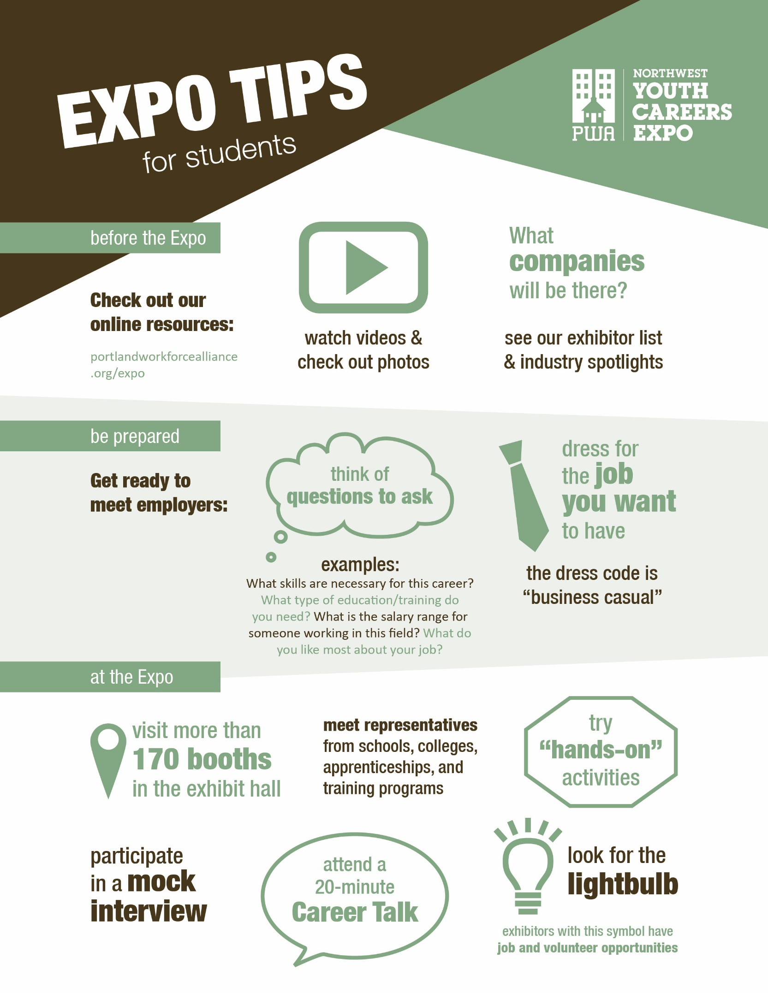

USE BEFORE THE EXPO
2018 NW Youth Careers Expo Name: Grade:
Pre-Event Questions
MAKE A PLAN!
- Which best describes you?
- I’m a hands-on type of person.
- I’m a people person!
- I’m the idea person.
- I’m the information and data person.

- Which Career Pathways might be a good fit for you?

- Arts & Communication
Career fields include designer, artist, writer, musician, public relations professional, communications specialist.

- Business & Management
Career fields include finance, accounting, marketing, sales, human resources.

- Health & Medical Services
Career fields include doctor, physical therapist, nurse, radiologist, medical lab technologist.

- Human Services & Helping Professions
Career fields include police officer, detective, teacher, counselor, psychologist, social worker, family support, nonprofit work, fire/emergency services.

- Industrial & Engineering Systems
Career fields include computer software engineer, civil engineer, electrician, architect, manufacturing, construction.

- Natural Resources & Science
Career fields include veterinary services, agriculture, horticulture, wildlife, forestry, fisheries, environmental scientist, landscape architect.

- I have no clue! However, I would like to talk with …..
over
- You will get an Expo Guide listing all of the exhibitors. The index will list companies and schools by Career Pathway. Using the career pathway(s) listed above, write in companies and/or schools that you would like to visit today and find them on the map in the brochure.

- Here’s one great way for high school students to get experience in a career area while in high school: community service and volunteering! Identify at least one exhibitor who offers community service and volunteer experience for youth (i.e. Mercy Corps, American Red Cross, Portland Parks and Rec, Oregon Humane Society, etc).

- Looking for a job, internship or community service opportunity? The Portland Human Resources Managers Association brings more than 100 human resource managers to interview students. Before you visit this area, write one or two questions you think a supervisor might ask you and prepare answers. You can review this with one of the human resource managers.

- What do you hope to get out of the event today?

USE DURING THE EXPO
2018 NW Youth Careers Expo Name: Grade:
Pre-Event Questions
CAREERS EXPO ASSIGNMENT

Practice talking to adults about the world of work.
Career Related Learning Experiences are required for graduation. This short assignment is your proof of participation.

Pick a company that you don’t know much about and
visit its booth to collect information.

Ask 3 – 5 questions so you can write a one-paragraph summary about the company. You can use the following big and small questions with everyone you meet, but you only have to write a summary about one company. Make up some questions of your own, too.

BIG questions:
- What do you want teens to know about your company?
- How has your business changed to adapt to changes in the industry, economy or culture?
- Where do you think your company will be in years when I get out of high school/college?
What kind of jobs will you be hiring for?

SMALL questions:
- What does your company do?
- How many people work for you in Oregon? Worldwide?
- I’m a (people person/hands-on, etc.) type of person.
What kinds of work does your company have for a person like me?
- What kind of educational paths would you recommend for someone who wanted to work at your company? What kinds of classes, training or experiences would be helpful?
- What are some entry-level jobs that high school graduates can get?
- Do you offer internships or summer employment?
My favorite part of the Expo was:

Company Summary:

USE AFTER THE EXPO
2018 NW Youth Careers Expo Name: Grade:
Pre-Event Questions
CAREERS EXPO REFLECTION

Pick one of the industry areas that you visited during the Expo:

❑ Arts & Communication  Business & Management  Manufacturing & Technology
❑ Natural Resources  Human Services (law, public service)  Health Care

Within this industry, what type of career(s) are you interested in?

Explain why this area interested you:

Describe three things that you learned about this industry that you didn’t know before:

1.

2.

3.

over
What type of education or training do you need to get started in this industry?
What type do you need to advance?

What kinds of skills do you need to succeed in this industry? (i.e. math skills, writing ability, computation skills, critical thinking, public speaking, budget analysis, project management)

List three personal attributes that this employer is looking for in a new employee (i.e. teamwork, creativity, punctuality, etc).

1.

2.

3.

OPTIONAL PERMISSION SLIP TEMPLATE
2018 NW Youth Careers Expo Name: Grade:
NW YOUTH CAREERS EXPO
Tuesday, March 13, 2018
Oregon Convention Center
777 NE MLK Blvd., Portland, OR 97232
www.portlandworkforcealliance.org/expo

Students are invited to participate in the NW Careers Expo with more than 100 employers and exhibitors providing essential career information. Students will learn about opportunities in Business, Health Services, Technology, Arts, Manufacturing, Construction and Natural Resources. Students will also have a chance to participate in mock interviews, learn about college programs & more. Participating in the NW Careers Expo counts as CRLE (Career Related Learning Experience) toward your diploma requirements.

Questions?
School contact name: Email/phone:

Parents/guardians: Please sign the form below so your child may participate in the NW Careers Expo.
A signed form functions as permission for your child to be included in Expo photos/communications.

has my permission to attend the NW Youth Careers Expo on Tuesday, March 13, 2018, at the Oregon Convention Center.
Parent/Guardian Name: (PRINT) | Parent/Guardian Signature:
Emergency Contact Name: | Emergency Contact Phone:
Student Agreement: By signing this form, I am agreeing to the below guidelines. I agree to:
- follow business-casual dress code. No hats, shorts, sweats, bare midriff, short skirts, ripped jeans.
- participate in the learning activities and engage in dialogue (ask questions) of Expo representatives.
- use respectful communication that is professional in both language and tone and that reflects positively on myself and the school I am representing.
- thank the employers I spoke with for their time.
Student Name: (PRINT) | Student Signature:

